Titanic Questions and Answers
- What factors most influenced survival on the Titanic?
Gender, age and class are the biggest survival factors in this data with those from the upper class surviving, on average, more than those of middle and lower class. Furthermore, that survival is heavily skewed with female’s taking a large portion of that survival rate as well as those 19 and under having a higher rate of survival, regardless of class or gender.

- How did survival rates differ by passenger class?
Rate of survival declined as social class reduced. Notably, survival rate decline was similar from upper to middle when compared to middle to lower (16% and 15% difference).
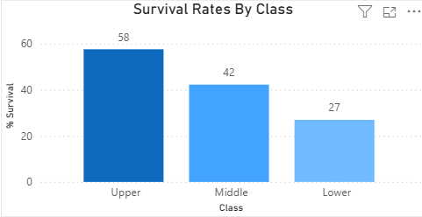

- Did gender significantly impact survival chances?
Yes, significantly. Overall, there is a 70% difference between the overall survival rate of males and females. However, this is also dependant on social class. Upper class males were most likely to survive as were their female counterparts (25% and 98%) whereas middle class males were less likely to survive (10% vs 94%). And both lower class male and female were less likely to survive than the other classes, although females still had a higher chance than males (67% and 10%).
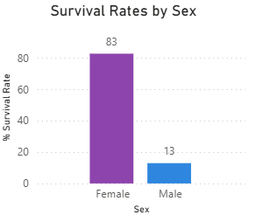
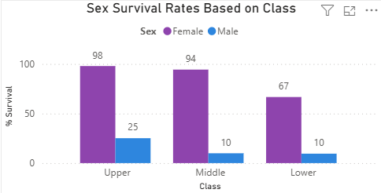

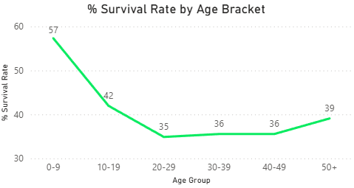
- How did age affect survival probability?





The youngest passengers (children) had a significantly higher survival rate when compared to the overall likelihood by 20%. Older children and teens were more likely to survive with 5% higher survival rate compared to overall. Whereas young adults until 50+ were slightly below the overall survival rate and 50+ had a minute improvement on survival compared to overall.
This highlights that children (and young people) were prioritised resulting in a higher survival rate. However, as the remainder of the age groups sit around the overall survival rate, other factors, such as gender and class, are likely responsible for the proportions of those who survived within that age rage.

- Were passengers traveling alone more or less likely to survive?
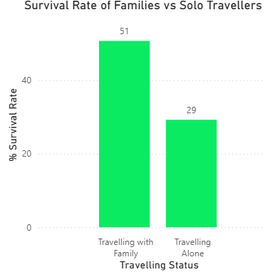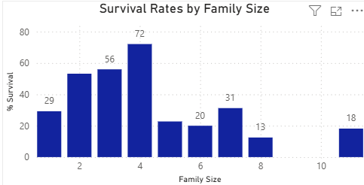
Individuals who travelling alone had a lower survival rate than those who travelled with families (29% for solo travellers’ vs 51% overall for those who travelled with family).
However, when looking at all family sizes, we can see that the likelihood deceases further when comparing solo travellers with travellers who had a family of 2-4 people with the largest difference in survival rate being when compared to a family of 4 (72% vs 29% survival).
Furthermore, solo travellers had a higher survival rate when compared to a family of 5 or higher, with the exception of a family of 7 where the difference is minimal.

- Is there an interaction between class and gender?

While women of all class were prioritised, significantly higher than men, there was a drop off in survival rate for women of ‘lower’ class. Suggesting that women were prioritised based on their class as evidenced by a declining survival rate from upper to middle and a drop to lower.

- Did family size influence survival?
Yes. Family sizes of 2-4 had a higher survival rate than any other family size.
With overall survival being 38%, these are the only family sizes that are linked to increased overall survival. Interestingly, solo travellers (family size of 1) had a higher survival rate than most of the remaining family sizes (5+ with the exception of 7 but only by a small amount).


- Were wealthier passengers more likely to survive within the same class?
Wealthier passengers (upper class) were slightly less likely to survive based on their ticket price (our indication of being wealthier). However, it does indicate a slight decrease in survival likelihood, it is incredibly small. As such, it appears as if there is little to no relationship wealthier passengers and their survival rate within the same class (upper).
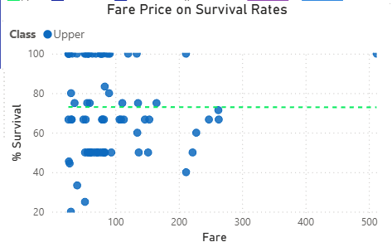
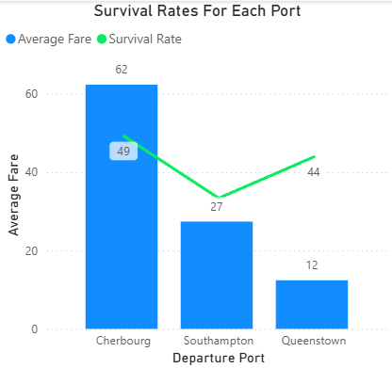
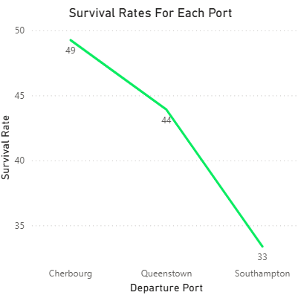
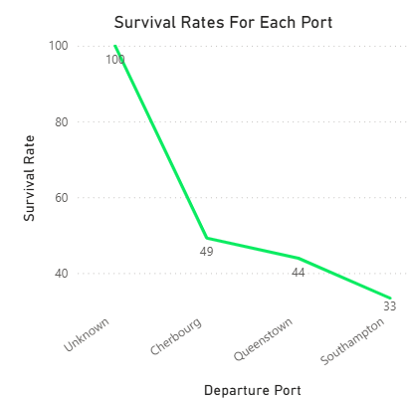
- Did port of embarkation impact survival, and why might that be?

‘Unknown’ category was removed due to being for 2 individuals and skewing results.
Cherbourg had the highest survival rate as well as the highest average fare with 52% of passengers being that of upper class. As upper class has a higher survival rate and it has the highest proportion of passengers being upper class out of the 3 ports, it is likely that that played a significant role in the port having a higher survival rate.
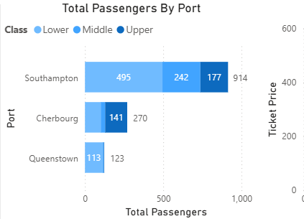
Queens Town had the highest proportion of lower-class passengers (92%) as well as the lowest survival rate. As above, lower-class passengers had the lowest survival rate, especially men. As such, it makes sense that a port with such a high proportion would have a low survival rate.
Southampton has more of a spread of class’, however, still has 54% lower class which explains the decrease in survival, as well as only having 19% upper class (the proportional difference likely explains why Cherbourg has such a higher survival rate).
- Was the “women and children first” rule actually followed consistently across all classes?
For the most part, women and children were evacuated first, with the exception of male children whose survival rate of 29% was far lower than the next lowest survival rate of female toddlers is 50%. However, it is important to note that while this appears to highlight that it was not followed, there were significantly fewer toddlers and baby’s onboard means this result is unreliable and should not be taken at face value due to the lack of sample size. As such, everything else suggests that women and children were prioritised over men, although class played a role in whether they were high priority or low priority.
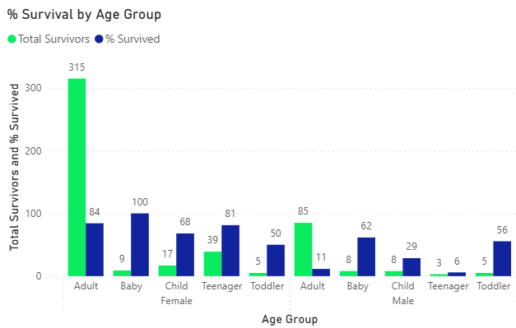
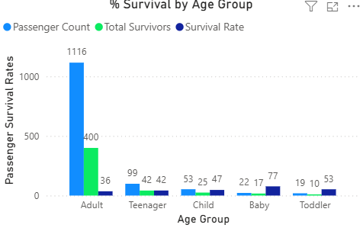
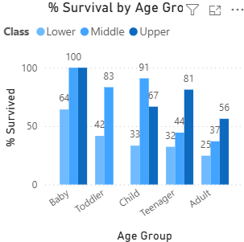
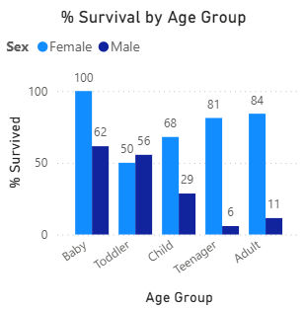

- Who were the most disadvantaged groups, and why?
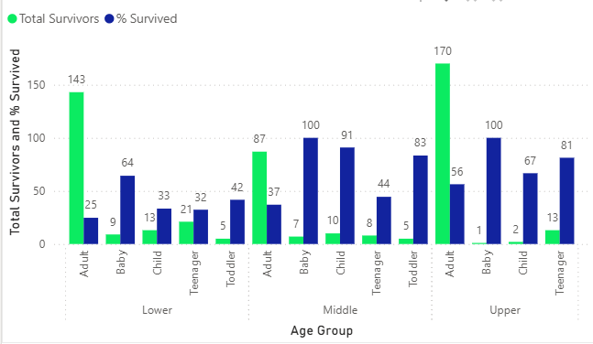
Overall, adults within the lower class had the lowest survival rate and were at the biggest disadvantage. Furthermore, if we break this down, we can see that males of all classes had a lower survival rate than females by a significant amount. Males of the lower class were the most disadvantaged group and fits with the motive of the era of ‘women and children first’ and is then skewed by societal norms
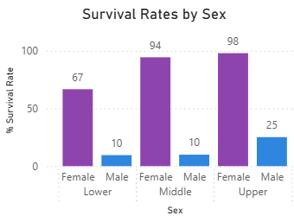

- What patterns suggest systemic inequality during evacuation?
Class: lower class was the only class to have their survival rate be lower than that of the overall survival rate. Furthermore, as class changes ‘goes up’, as does survival rate.
Gender: Women were significantly more likely to survive than men and this is true across all classes. However, while middle class and upper-class survival for women is similar (94% and 98%), there is a steep decrease to the women in lower class (67%). Indicating that even though women were priorities, class inequity was still prevalent here.
Family Size: Individuals who had a family size of 2-4 had a higher survival rate (53% - 72%) compared to the overall survival rate of 38%. Whereas all other family sizes having lower than the overall with no clear pattern based on size for 5+
Age: Children (4-12), baby’s (0-1) and toddlers (2-3) had the highest overall survival (47%, 77%, 53%. With survival rate dropping as age increased, 42% for teenagers (13-18) and 36% for adults (19+).

